CSCI 325 Team Project
Requirements Documentation
Project: Student Study Planner System
Course: Object-Oriented Programming (Summer I 2026)
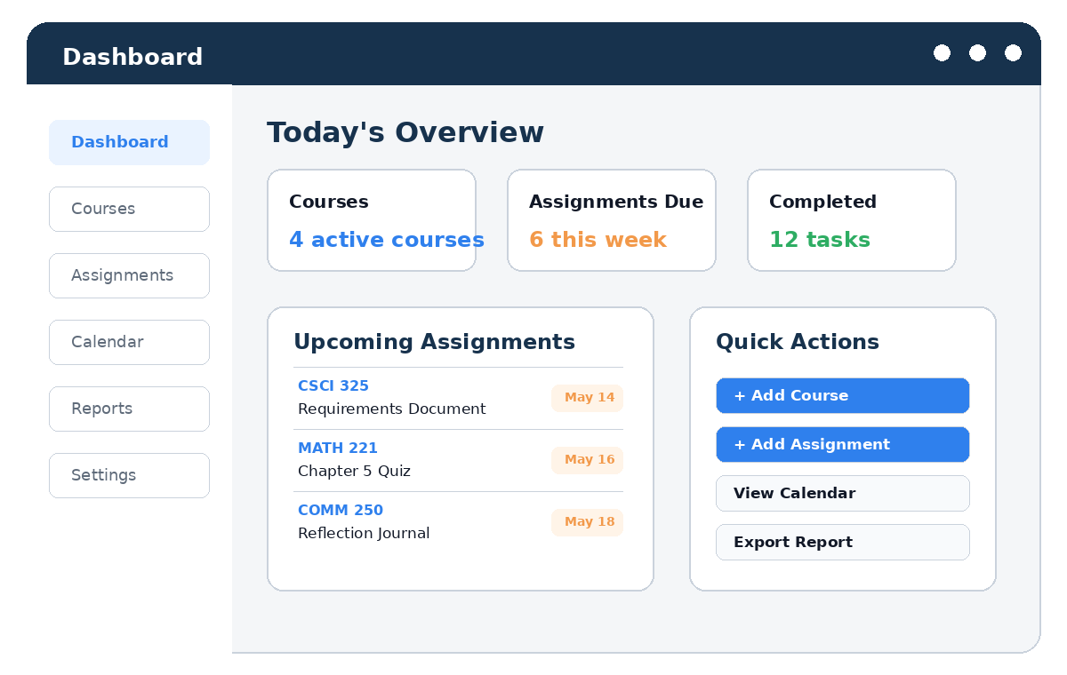
Prepared by: Huu Hoang Do, Shane Mathis, Brandon Musch, Jamal Shipman
Repository: https://github.com//student-study-planner
Submission Method: GitHub

Table of Contents
Section | Page
1. Project Abstract | 3
2. Team Members | 3
3. GitHub Repository Location | 3
4. Detailed Program Description | 3
5. Functional and Non-Functional Requirements | 4
6. User Interface Description and GUI Mockups | 4
7. Division of Labor | 8
8. UML Use Case Diagram | 8
9. Use Case Descriptions | 8
10. Team Communication Plan | 13

1. Project Abstract
The Student Study Planner System is a desktop GUI application designed to help college students organize courses, assignments, exams, study sessions, and progress reports in one place. The user can create courses, add assignments, view a calendar, mark tasks as complete, and generate a simple progress report. The goal of the program is to improve student organization while demonstrating object-oriented programming concepts such as classes, objects, encapsulation, inheritance, and modular design. The program is intentionally designed at a beginner-friendly course level so that a small CSCI 325 team can complete it during the semester using C++, file input/output, and a simple GUI framework or console-simulated GUI if needed.

2. Team Members
Team Member | Role | Main Responsibility | Backup Responsibility
Huu Hoang Do and Shane Mathis | Project Lead / GUI Designer | Design GUI screens, prepare UML diagram, organize final documentation | Help with testing and GitHub commits
Brandon Musch and Jamal Shipman | Backend Developer | Create Course, Assignment, and Planner classes | Help debug file input/output
Huu Hoang Do, Shane Mathis, Brandon Musch and Jamal Shipman | Testing / GitHub Manager | Create test cases, manage repository, verify program output | Help build calendar and report features

3. GitHub Repository Location
Repository URL: https://github.com//student-study-planner
The team will use GitHub to store source code, documentation, GUI mockup images, UML diagrams, test files, and the final requirements document. Each team member will commit work under their own account so that the professor can see participation and progress.

4. Detailed Program Description
When the program starts, the user will see a login screen. After logging in, the user will be taken to a dashboard that shows active courses, upcoming assignments, and quick actions. From the dashboard, the user can add courses, add assignments, view the calendar, mark tasks complete, and generate a progress report. Data will be stored in text files so the user can close the program and still see saved courses and assignments later.

4.1 Main Program Features
- Login to the planner system using a simple username and password screen.
- Create and manage courses such as CSCI 325, MATH 221, or COMM 250.
- Add assignments with a name, course, due date, priority, and description.
- Edit or delete assignments if the user makes a mistake.
- View assignments in a dashboard list and in a monthly calendar view.
- Mark assignments as complete when work is finished.
- Generate a progress report that shows task completion by course.
- Save and load data from text files using file input/output.

4.2 Intended Users
The intended user is a college student who wants a simple tool to keep track of class responsibilities. The program does not need internet access or a real database. It is designed as a course project that can be implemented with the programming skills covered in an object-oriented programming class.

5. Functional and Non-Functional Requirements

5.1 Functional Requirements
- The system shall allow the user to log in.
- The system shall allow the user to create a course.
- The system shall allow the user to add a new assignment.
- The system shall allow the user to edit assignment information.
- The system shall allow the user to delete an assignment.
- The system shall allow the user to view assignments by course and due date.
- The system shall allow the user to mark an assignment as complete.
- The system shall allow the user to generate a progress report.
- The system shall save and load information from files.

5.2 Non-Functional Requirements
- The GUI should be easy to understand for beginner users.
- The program should validate input such as blank assignment names or invalid due dates.
- The program should use clear class names and meaningful variable names.
- The program should be organized into multiple files instead of one large file.
- The program should be tested using normal and incorrect input cases.
- The program should run on the computers used for the course.

6. User Interface Description and GUI Mockups
The program will use a graphical user interface. Users will interact with buttons, text boxes, drop-down menus, tables, and calendar-style views. The GUI is meant to be simple and similar to common student planning applications.

Figure 1. Login Screen Mockup
The login screen allows the student to enter a username and password before accessing saved planner information.
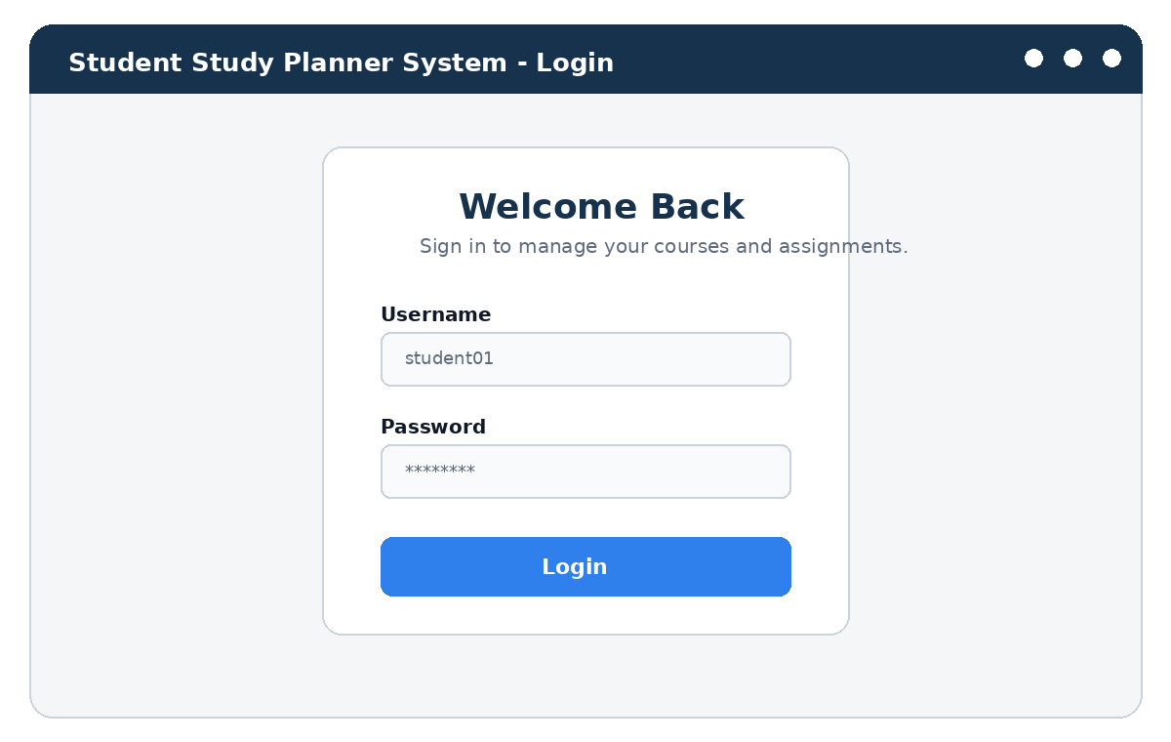
Figure 1. Login Screen Mockup

Figure 2. Dashboard Screen Mockup
The dashboard provides a quick summary of courses, upcoming assignments, completed tasks, and shortcut buttons.

Figure 2. Dashboard Screen Mockup

Figure 3. Add Assignment Screen Mockup
The add assignment screen collects the course, assignment name, due date, priority, and description.
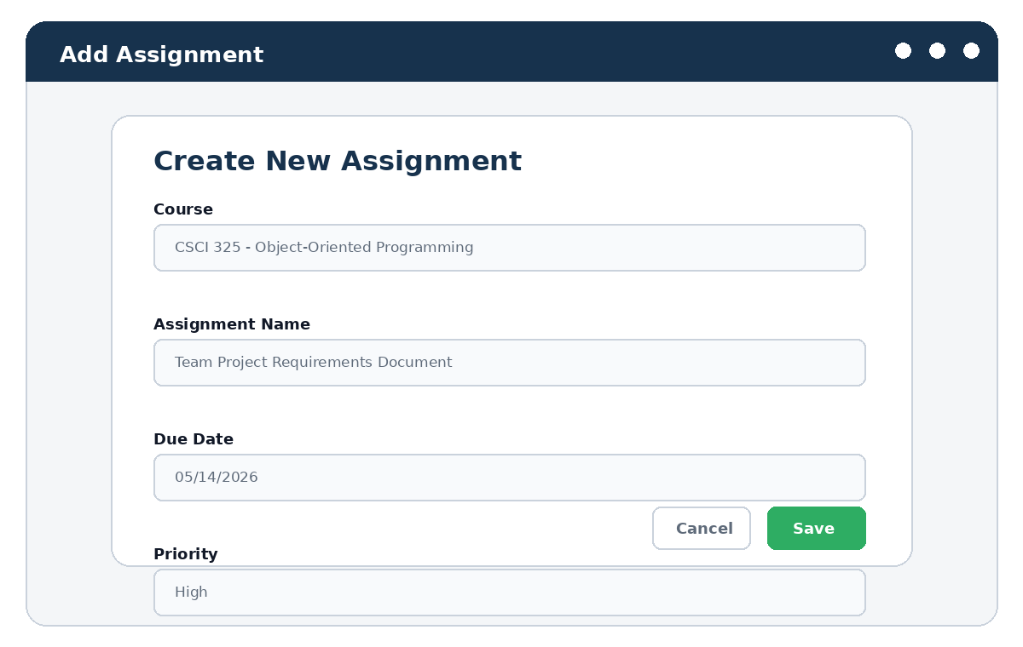
Figure 3. Add Assignment Screen Mockup

Figure 4. Calendar View Mockup
The calendar screen displays assignments by due date so the student can plan ahead.
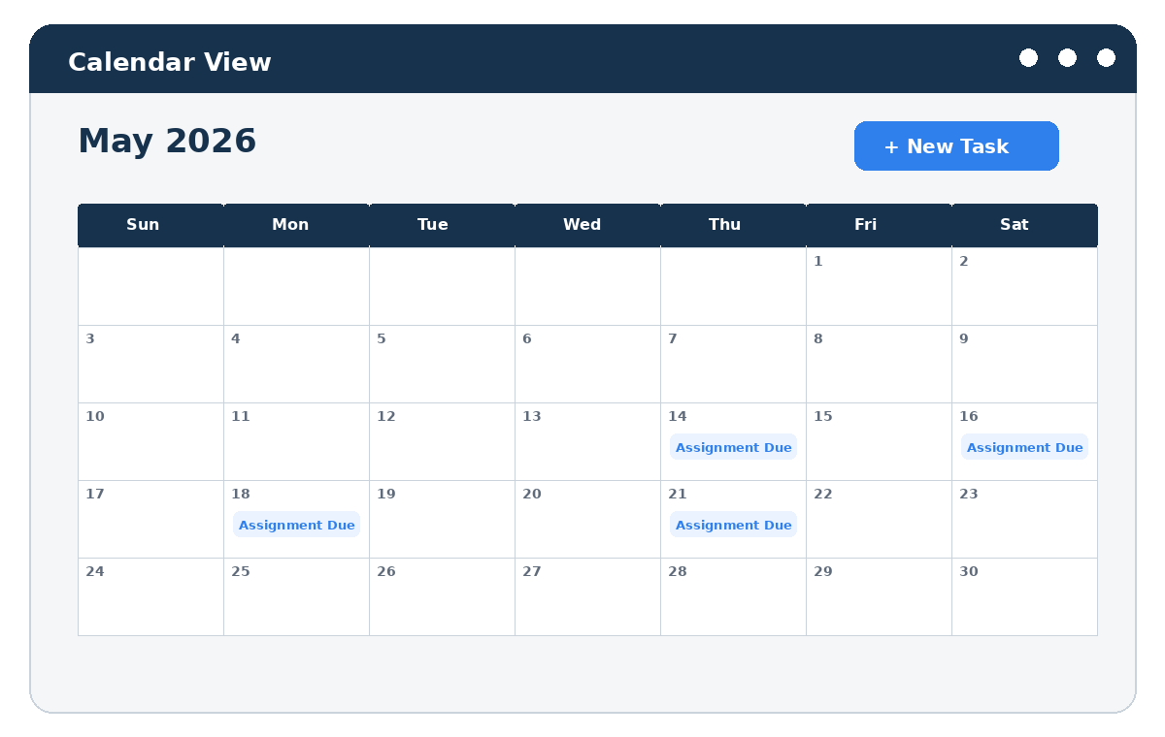
Figure 4. Calendar View Mockup

Figure 5. Progress Report Mockup
The progress report screen shows course completion percentages and allows the user to export a report.
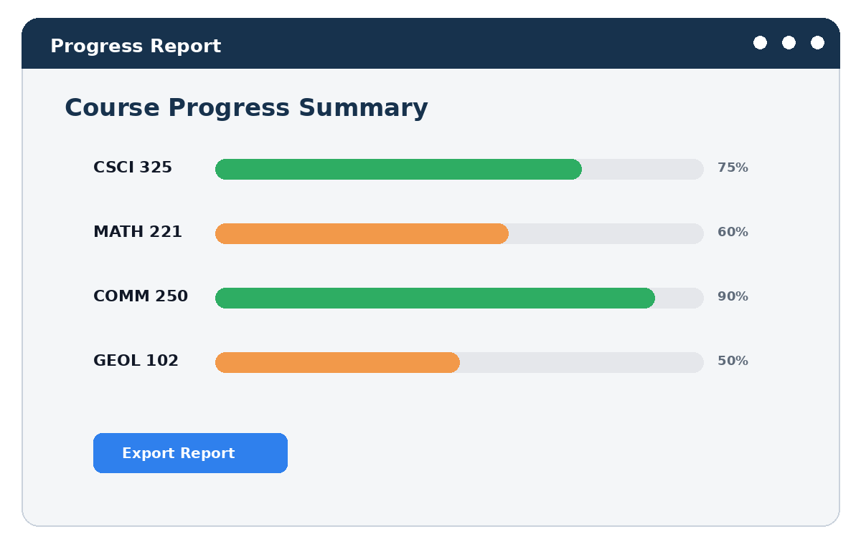
Figure 5. Progress Report Mockup

7. Division of Labor
Team Member | Assigned Use Cases | Program Files / Classes | Deliverables
Huu Hoang Do and Shane Mathis | Login, View Calendar, Generate Progress Report | LoginWindow, CalendarView, ReportGenerator | GUI mockups, UML diagram, final Word document
Brandon Musch and Jamal Shipman | Create Course, Add Assignment, Edit Assignment | Course, Assignment, PlannerManager | Backend logic and data validation
Huu Hoang Do, Shane Mathis, Brandon Musch and Jamal Shipman | Delete Assignment, Mark Task Complete, Save/Load Data | FileManager, TestDriver | Testing plan, GitHub setup, README file

8. UML Use Case Diagram
The UML diagram below shows how the Student actor interacts with the main features of the Student Study Planner System.
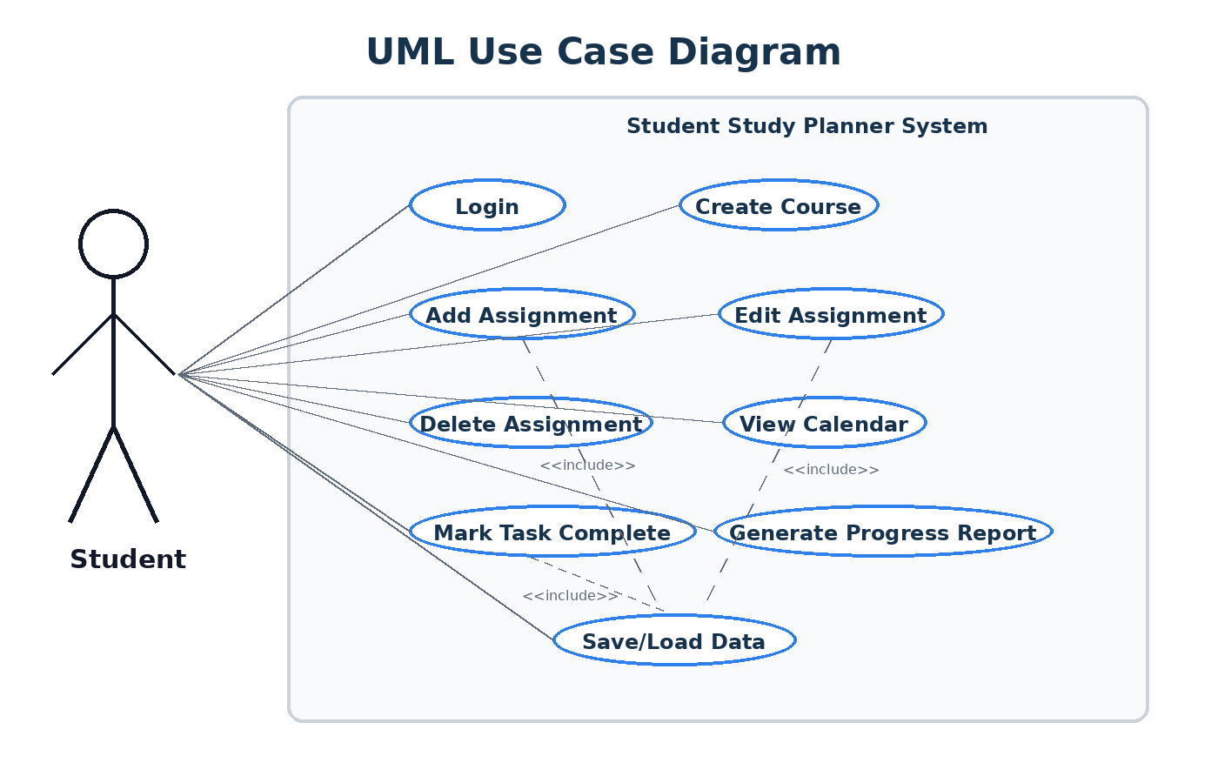
Figure 6. UML Use Case Diagram for Student Study Planner System

9. Use Case Descriptions

UC-01: Login
Use Case (Name) | Login
ID | UC-01
Scope | Main GUI
Priority | High
Summary | The user enters login information to access saved planner data.
Primary Actor | Student
Supporting Actors | System
Stakeholders | Student wants secure access to the planner. Team wants the program to load the correct saved data.
Generalization | None
Include | Save/Load Data
Extend | Error message for invalid login
Precondition | Program is launched.
Trigger | User clicks the Login button.
Normal Flow | 1. System displays the login screen.  2. User enters username and password.  3. System checks that the fields are not blank.  4. System validates login information.  5. System opens the dashboard.
Sub Flows | Input validation and file saving may occur during this use case.
Alternate Flow / Exceptions | - If the username field is blank, system asks user to enter a username.  - If the password field is blank, system asks user to enter a password.  - If login is incorrect, system displays an error and stays on login screen.
Post-Condition | The dashboard is displayed and user data is loaded.
Open Issues | Will the final version need account creation or only a default student login?

UC-02: Create Course
Use Case (Name) | Create Course
ID | UC-02
Scope | Course Management
Priority | High
Summary | The user creates a course that assignments can be connected to.
Primary Actor | Student
Supporting Actors | System
Stakeholders | Student wants to organize assignments by course.
Generalization | None
Include | Save/Load Data
Extend | Edit Course in a future version
Precondition | User is logged in.
Trigger | User clicks Add Course.
Normal Flow | 1. System displays Add Course form.  2. User enters course name, course code, professor name, and meeting days.  3. System validates required fields.  4. System creates a Course object.  5. System saves the new course to file.  6. System returns to dashboard or course list.
Sub Flows | Input validation and file saving may occur during this use case.
Alternate Flow / Exceptions | - If course name is blank, system displays a required field message.  - If the same course already exists, system asks whether to update it or cancel.
Post-Condition | A new course is stored and available for assignments.
Open Issues | Should courses allow color coding?

UC-03: Add Assignment
Use Case (Name) | Add Assignment
ID | UC-03
Scope | Assignment Management
Priority | High
Summary | The user adds a new assignment with a due date and priority.
Primary Actor | Student
Supporting Actors | System
Stakeholders | Student wants to track academic deadlines.
Generalization | None
Include | Save/Load Data
Extend | Validation for due date
Precondition | User is logged in and at least one course exists.
Trigger | User clicks Add Assignment.
Normal Flow | 1. System displays Add Assignment form.  2. User selects a course.  3. User enters assignment name, due date, priority, and description.  4. System validates the input.  5. System creates an Assignment object.  6. System saves the assignment to file.  7. System displays the new assignment on dashboard and calendar.
Sub Flows | Input validation and file saving may occur during this use case.
Alternate Flow / Exceptions | - If no course exists, system asks user to create a course first.  - If due date format is invalid, system asks user to correct it.  - If assignment name is blank, system displays an error.
Post-Condition | The new assignment appears in planner views.
Open Issues | Should the program support recurring assignments?

UC-04: Edit Assignment
Use Case (Name) | Edit Assignment
ID | UC-04
Scope | Assignment Management
Priority | Medium
Summary | The user changes information for an existing assignment.
Primary Actor | Student
Supporting Actors | System
Stakeholders | Student wants to fix mistakes or update due dates.
Generalization | None
Include | Save/Load Data
Extend | None
Precondition | At least one assignment exists.
Trigger | User clicks Edit beside an assignment.
Normal Flow | 1. System displays current assignment information.  2. User changes one or more fields.  3. System validates updated information.  4. System saves the changes.  5. System refreshes dashboard and calendar.
Sub Flows | Input validation and file saving may occur during this use case.
Alternate Flow / Exceptions | - If the user clicks Cancel, no changes are saved.  - If new due date is invalid, system keeps the edit form open.
Post-Condition | Assignment information is updated.
Open Issues | Should previous versions be stored?

UC-05: Delete Assignment
Use Case (Name) | Delete Assignment
ID | UC-05
Scope | Assignment Management
Priority | Medium
Summary | The user removes an assignment from the planner.
Primary Actor | Student
Supporting Actors | System
Stakeholders | Student wants to remove assignments that no longer matter.
Generalization | None
Include | Save/Load Data
Extend | Confirmation dialog
Precondition | At least one assignment exists.
Trigger | User clicks Delete beside an assignment.
Normal Flow | 1. System asks user to confirm deletion.  2. User confirms deletion.  3. System removes the assignment from memory.  4. System updates the saved file.  5. System refreshes dashboard and calendar.
Sub Flows | Input validation and file saving may occur during this use case.
Alternate Flow / Exceptions | - If user cancels, assignment remains unchanged.  - If file saving fails, system displays an error message.
Post-Condition | Assignment is removed from the planner.
Open Issues | Should deleted assignments be recoverable?

UC-06: View Calendar
Use Case (Name) | View Calendar
ID | UC-06
Scope | Calendar View
Priority | High
Summary | The user views assignments organized by month and due date.
Primary Actor | Student
Supporting Actors | System
Stakeholders | Student wants to see upcoming workload visually.
Generalization | None
Include | Load Data
Extend | Filter calendar by course
Precondition | User is logged in.
Trigger | User clicks Calendar.
Normal Flow | 1. System loads assignments from memory.  2. System displays current month.  3. System places assignment labels on due dates.  4. User can move to next or previous month.  5. User can click an assignment to view details.
Sub Flows | Input validation and file saving may occur during this use case.
Alternate Flow / Exceptions | - If there are no assignments, system displays an empty calendar message.  - If a date has many assignments, system shows a small list or popup.
Post-Condition | Calendar view is displayed.
Open Issues | Should calendar export to PDF be included?

UC-07: Mark Task Complete
Use Case (Name) | Mark Task Complete
ID | UC-07
Scope | Assignment Management
Priority | High
Summary | The user marks an assignment as complete after finishing it.
Primary Actor | Student
Supporting Actors | System
Stakeholders | Student wants to track progress and avoid repeating completed work.
Generalization | None
Include | Save/Load Data
Extend | Generate Progress Report
Precondition | At least one incomplete assignment exists.
Trigger | User clicks Mark Complete.
Normal Flow | 1. System changes assignment status to complete.  2. System records completed date.  3. System updates dashboard completion count.  4. System saves updated assignment data.
Sub Flows | Input validation and file saving may occur during this use case.
Alternate Flow / Exceptions | - If user accidentally marks complete, user can edit assignment and change status back to incomplete.
Post-Condition | Assignment status is complete and progress values update.
Open Issues | Should completed assignments be hidden by default?

UC-08: Generate Progress Report
Use Case (Name) | Generate Progress Report
ID | UC-08
Scope | Reports
Priority | Medium
Summary | The user generates a report showing completed and incomplete work by course.
Primary Actor | Student
Supporting Actors | System
Stakeholders | Student wants a quick summary of academic progress.
Generalization | None
Include | Load Data
Extend | Export report in future version
Precondition | User is logged in and assignment data exists.
Trigger | User clicks Reports.
Normal Flow | 1. System counts assignments by course.  2. System calculates completion percentages.  3. System displays progress bars or a summary table.  4. User may export or print the report.
Sub Flows | Input validation and file saving may occur during this use case.
Alternate Flow / Exceptions | - If no assignments exist, system displays a message that there is not enough data.  - If export fails, system still displays the report on screen.
Post-Condition | Progress report is displayed.
Open Issues | Should report include GPA or grades in a future version?

UC-09: Save/Load Data
Use Case (Name) | Save/Load Data
ID | UC-09
Scope | File Management
Priority | High
Summary | The system saves and loads courses, assignments, and completion status using files.
Primary Actor | Student
Supporting Actors | File System
Stakeholders | Student wants information to remain after closing the program.
Generalization | None
Include | None
Extend | Error handling
Precondition | Program starts or data changes.
Trigger | Program opens or user saves data.
Normal Flow | 1. When program starts, system checks for saved files.  2. System loads courses and assignments into objects.  3. When user changes data, system writes updated data to file.  4. System confirms save was successful.
Sub Flows | Input validation and file saving may occur during this use case.
Alternate Flow / Exceptions | - If file does not exist, system starts with empty data.  - If file is corrupted, system displays an error and starts safely.  - If save fails, system notifies user.
Post-Condition | Planner data is available between program sessions.
Open Issues | Should the data be stored as text, CSV, or JSON?

10. Team Communication Plan:
The team will communicate using GroupMe for daily messages and Blackboard Discussion Board for official course communication

